

June 2020

Category review: Chips

Retail Analytics



Classification: Confidential

1

# Our 17 year history assures best practice in privacy, security and the ethical use of data

We all have a responsibility to use data for good

Privacy

* We have built our business based on privacy by design principles for the past 17 years
* Quantium has strict protocols around the receipt and storage of personal information
* All information is de-identiﬁed using an irreversible tokenisation process with no ability to

re-identify individuals.

Security

* We are ISO27001 certiﬁed - internationally recognised for our ability to uphold best practice standards across information security
* We use ‘bank grade’ security to store and process our data
* Comply with 200+ security requirements from NAB, Woolworths and other data partners
* All partner data is held in separate restricted environments
* All access to partner data is limited to essential staff only
* Security environment and processes regularly audited by our data partners.

Ethical use of data

Applies to all facets of our work, from the initiatives we take on, the information we use and how our solutions impact individuals, organisations and society.

Quantium believes in using data for progress, with great

care and responsibility. As such please respect the commercial in conﬁdence nature

## of this document.



2

Classification: Confidential

# Executive summary

Chips Category Review

1

Trial Store Analysis

2

* Chips transactions increase substantially prior to Christmas. It is a good time to take advantage of this momentum with promotional offers.
* Older and Young Family segment have the highest average purchase units per unique customer.
* Sales mainly came from Budget - older families, Mainstream - young singles/couples, and Mainstream - retirees. In total contributing 25% of sales revenue.
* Trial store 77 and 86 experienced signiﬁcant increase in Total Sales and Customers quantity during the trial period compared to their control stores..
* Trial store 88 experience increase as well, but insigniﬁcant compared to its’ Control store.

3

01

# Category

4

# Sales increase steadily approaching Christmas, and return again to early December sales level during New Year Eve. Dipped sales in 25th December was due to shops being non-operational during Christmas.

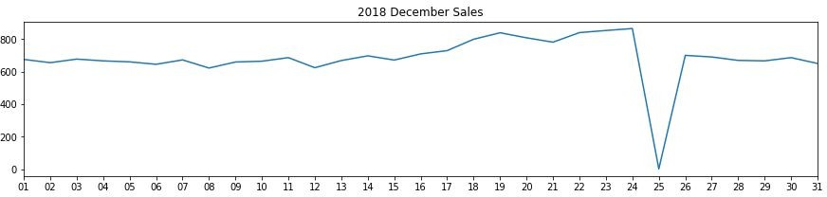

5

# Aﬄuence doesn’t seem to affect quantity of purchase per customer.

Older and Young Family segment have the highest average purchase units per unique customer.

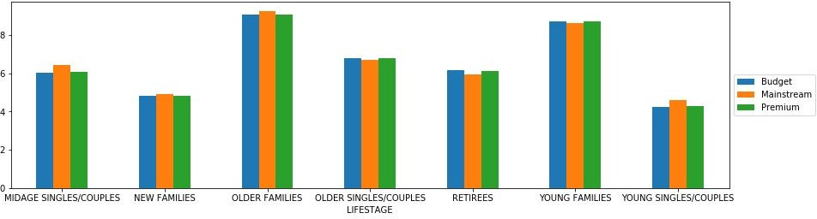

6

# Sales mainly came from Budget - older families, Mainstream - young singles/couples, and Mainstream - retirees. In total, older customers buy more than younger customers. Non-premium customers buy more than premium customers.

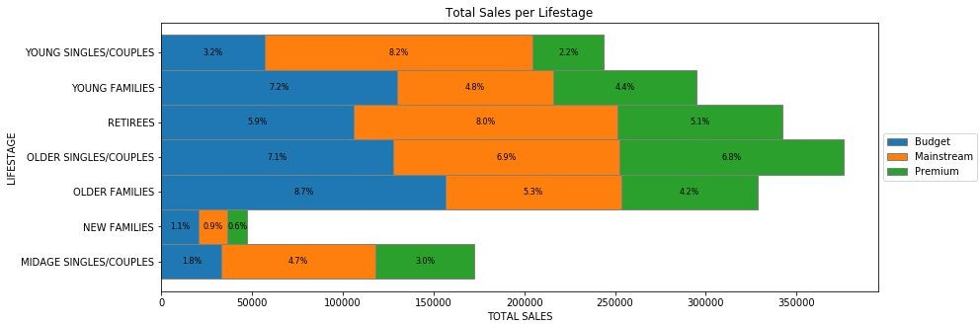

7

02

# Trial store performance

8

# Trial store 77 second and third month, and trial store 86 second month had signiﬁcantly higher sales than Control store.

Whereas trial store 88 sales increase is insigniﬁcant.

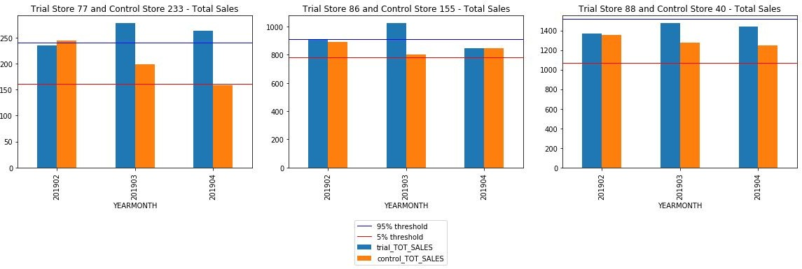

9

# Trial store 77 and 86 had signiﬁcant increase in number of customers during Trial period compared to Control stores, proving an effective trial run.

Whereas trial store 88 customers increase is insigniﬁcant.

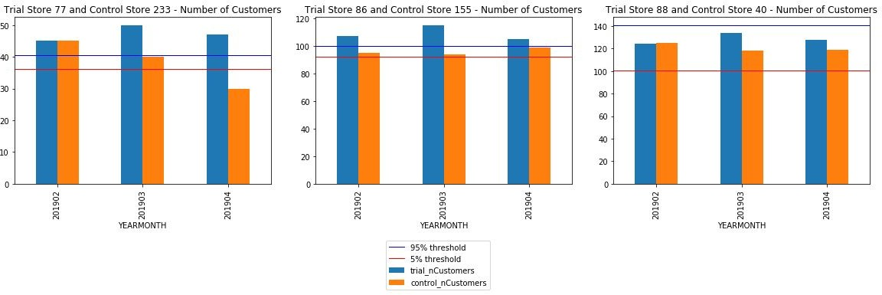

10

Disclaimer: This document comprises, and is the subject of intellectual property (including copyright) and conﬁdentiality rights of one or multiple owners, including The Quantium Group Pty Limited and its aﬃliates (Quantium) and where applicable, its third-party data owners (Data Providers), together (IP Owners). The information contained in this document may have been prepared using raw data owned by the Data Providers. The Data Providers have not been involved in the analysis of the raw data, the preparation of, or the information contained in the document. The IP Owners do not make any representation (express or implied), nor give any guarantee or warranty in relation to the accuracy, completeness or appropriateness of the raw data, nor the analysis contained in this document. None of the IP Owners will have any liability for any use or disclosure by the recipient of any information contained in, or derived from this document. To the maximum extent permitted by law, the IP Owners expressly disclaim, take no responsibility for and have no liability for the preparation, contents, accuracy or completeness of this document, nor the analysis on which it is based. This document is provided in conﬁdence, may only be used for the purpose provided, and may not be copied, reproduced, distributed, disclosed or made available to a third party in any way except strictly in accordance with the applicable written terms and conditions between you and Quantium, or otherwise with Quantium’s prior written permission

11